Task 6 – Participate in Professional Development

**Deliverable 1 – Industry Networking**

Below is my ticket for an Adelaide Game Dev Meetup I am attending to network with other people in the industry.

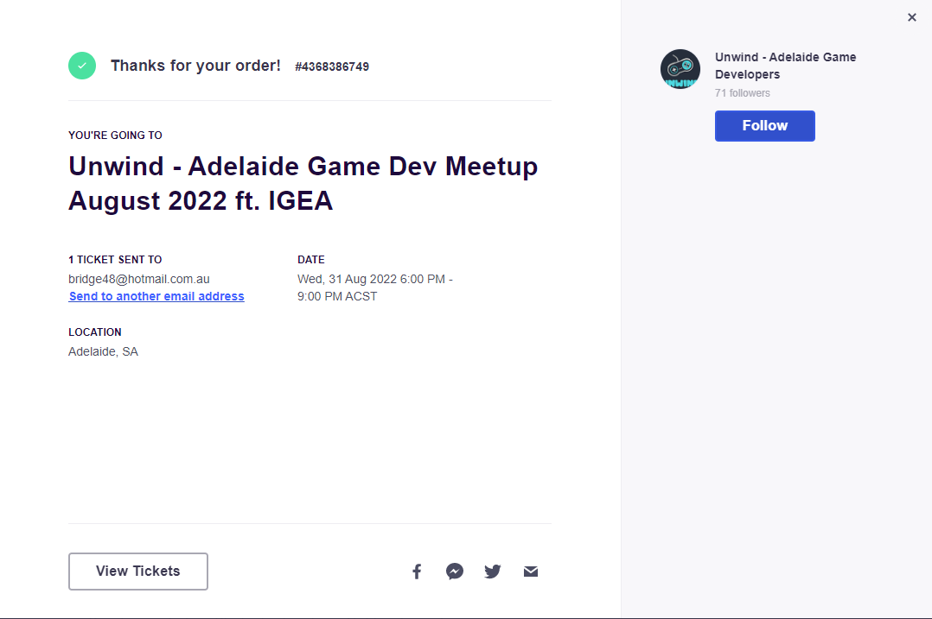

**Deliverable 2 – Self Evaluation**

|  |  |  |  |  |  |  |  |
| --- | --- | --- | --- | --- | --- | --- | --- |
| **Name:** | Luke Stanbridge | | | | **Date:** | 19/08/2022 | |
| **Quality of Work:**  I complete my work thoroughly and with care, correctly following established policies and procedures. | | | | | | | |
| Strongly Disagree | | Disagree | Neutral | Agree | | | Strongly Agree |
| **Comments:**  Sometimes if I am stretched for time, I only do the minimum required when I preferably would like to create something I’m proud of. | | | | | | | |
| **Job Knowledge:**  I have a full understanding of my role and responsibilities and perform my responsibilities skilfully. | | | | | | | |
| Strongly Disagree | | Disagree | Neutral | Agree | | | Strongly Agree |
| **Comments:**  If I don’t know or understand something I want to research and understand it. | | | | | | | |
| **Organisational Skills:**  I complete my work thoroughly and with care, correctly following established policies and procedures. | | | | | | | |
| Strongly Disagree | | Disagree | Neutral | Agree | | | Strongly Agree |
| **Comments:**  Always submit my work on time maybe a day late at max | | | | | | | |
| **Leadership Skills:**  I make good decisions and trust my peers when delegating tasks. My peers work to a higher standard when following my instructions. | | | | | | | |
| Strongly Disagree | | Disagree | Neutral | Agree | | | Strongly Agree |
| **Comments:**  I trust my peers and expect them to complete their tasks without me issuing too many instructions. I will help them as best I can if they have questions otherwise, I assume they are fine. | | | | | | | |
| **Teamwork:**  I actively participate when assigned to a group task. My peers complete the group task more efficiently and to a higher standard when I am assigned to their group task. | | | | | | | |
| Strongly Disagree | | Disagree | Neutral | Agree | | | Strongly Agree |
| **Comments:**  I am a good team player, being older I have had lots of experience working in teams for other industries. | | | | | | | |
| **Communication Skills:**  I communicate clearly in both written and verbal communication. I rarely must clarify and rarely cause confusion. | | | | | | | |
| Strongly Disagree | | Disagree | Neutral | Agree | | | Strongly Agree |
| **Comments:**  Confident with my communication skills. | | | | | | | |
| **Conduct:**  I conduct myself professionally. My language, tone, appearance, hygiene and attitude are exemplary. | | | | | | | |
| Strongly Disagree | | Disagree | Neutral | Agree | | | Strongly Agree |
| **Comments:**  I conduct myself professionally but also like a relaxed environment to work and study in. I understand when the different time that professional conduct is required and when it may not be. | | | | | | | |
| **Strengths:**  My strongest attributes, skills or other qualities are: | | | | | | | |
| **Comments:**  I complete my work on time and too a decent standard. Happy to ask questions and seek clarification when I need it. I have plenty of life experience which I feel is an advantage in this field. Keen to learn as much as I can to have a good career in game development. | | | | | | | |
| **Weaknesses:**  My weakest attributes, skills or other qualities are: | | | | | | | |
| **Comments:**  I have only been learning programming for about a year and a half and wish I started earlier. At times I could probably do some extra work outside of class to improve the quality of my assessments as it will only benefit me in the long run. | | | | | | | |
| **Challenges Pt. 1:**  My challenges are: | | | | | | | |
| **Comments:**  Improve my ability to learn things faster.  Make sure I turn up to all classes.  Just doing the bare minimum | | | | | | | |
| **Challenges Pt. 2:**  I plan to overcome these challenges by: | | | | | | | |
| **Comments:**  Familiarise myself with the technical aspects of programming, find I learn things better when shown than from someone telling me.  Prioritise class time highly.  Manage time better to allow for higher quality work. | | | | | | | |
| **Goals Pt. 1:**  My goals are: | | | | | | | |
| **Comments:**  Become a proficient programmer  Pass my course  Get a job in game development  Find a niche in game development to specialise in | | | | | | | |
| **Goals Pt. 2:**  I plan to achieve these goals by: | | | | | | | |
| **Comments:**  Focus on class and do extra courses outside of class to enforce my learning.  Hand in all assignments.  Start networking in industry, create a resume and portfolio.  Work out what parts of game programming I enjoy the most and research into these areas. | | | | | | | |

**Deliverable 3 – Professional Development**

Below is an image of all the extra courses I have undertaken on Udemy outside of class. Some of them I still need to finish but I have put a lot of hours into these outsides of class to try further my learning.

